* Right click below executable and press “run as admin”



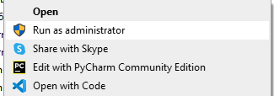

* Press yes below prompt
* 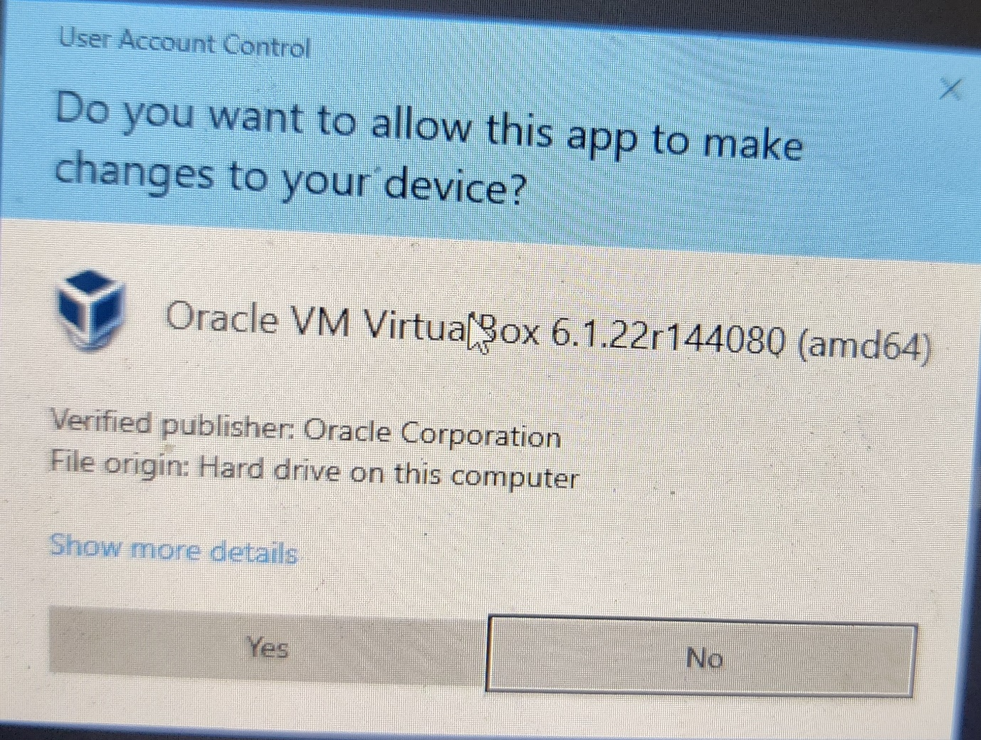
* Text

  Description automatically generated with medium confidence
* Graphical user interface, text, application

  Description automatically generated
* Graphical user interface, text, application, email

  Description automatically generated
* Text

  Description automatically generated
* Graphical user interface, text, application, email

  Description automatically generated
* Graphical user interface

  Description automatically generated with low confidence